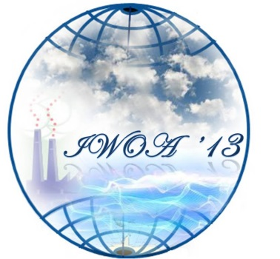
International Workshop on Ocean Acidification
Consequences for Marine Ecosystems
Workshop Registration Form
Registration Fees
Ph.D. Student- 3,500 INR
Postdoc- 4,500 INR
Faculty - 6,000 INR
Foreign Scientist - 200 $USD

Mode of payment of registration fee: Payment can be made by Demand Draft or A/C Payee Cheque in favour of ‘Indian Institute of Science Education and Research, Kolkata’ or by NEFT/RTGS to Indian Overseas Bank [S/B Account No of IISER-Kolkata is 089301000011530; IFSC Codes: IOBA0000893; MICR Code:700020029]

Postal Address: IISER Kolkata, Mohanpur Campus, PO: Krisi Viswavidyalaya,
Mohanpur - 741252, Nadia, West Bengal.

Details of Participants:
Name:
Age:
Male/Female:
Official Address (Institute/ University/ Department, City, Country):

Telephone Number:
Email Address:
Current Employment/ Position:
Highest Academic Qualifications:
Abstract [Abstract can be on marine organisms or marine ecosystem vulnerable to ocean acidification or directly related to ocean acidification impacts on marine biological systems]
Abstract Submitted – Yes/No
If yes, Title of Abstract:

