Title
N1. Surname1¹, N2. Surname2², N3. Surname3¹, …
¹Affiliation 1
²Affiliation 2
E-mail: abcde@email.com
The body of your abstract, the first paragraph starts without indent. Please use citations like this [1] or this [2,3,4] or this [2–4]. An inline equation can be added like $\vec{F}=−\vec{∇}V$, while a figure can be added like
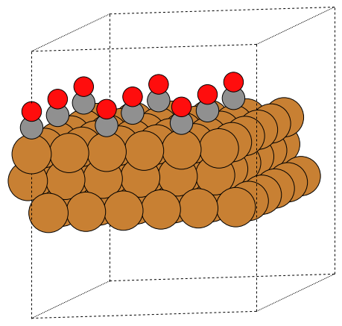

Figure 1: Adsorption on metal slab
For each new paragraph please use 1 cm indent for the first line. Overall abstract (including references) should not exceed one page.
[1] N1., Surname1, N2., Surname2, …., Journal Abbreviation Volume (Year) Page0–PageN.
[2] N1., Surname1, N2., Surname2, …., Journal Abbreviation Volume (Year) Page0–PageN.
[3] N1., Surname1, N2., Surname2, …., Journal Abbreviation Volume (Year) Page0–PageN.
[4] N1., Surname1, N2., Surname2, …., Journal Abbreviation Volume (Year) Page0–PageN.

